**BF #3 blower no 2 labyrinth seal replacement**

*Date: 06/05/2013*

Abnormal sounds were heard from the drive end side of the impeller of blower no 2 while the blower was being stopped for planned shutdown. The blower was then kept running on barring motor and rubbing sounds were heard from the drive end side. After checking, the blower was started again and was checked for abnormal sounds but was found to be OK.The vibration readings of the blower was also taken and was found to be OK.The readings were as follows.

|  |  |  |  |  |  |  |
| --- | --- | --- | --- | --- | --- | --- |
|  | FNDE | FDE | GBNDE | GBDE | MDE | MNDE |
| A | 7.1/1.3 | 7.6/1.4 | 3.3/0.65 | 6.2/0.74 | 41.3/3.3 | 10.6/1.1 |
| H | 14.1/1.6 | 5.6/1.4 | 7.8/0.9 | 7.5/1.92 | 6.0/0.65 | 7.0/0.67 |
| V | 4.1/1.4 | 3.3/1.8 | 4.7/0.78 | 3.5/0.72 | 8.0/0.64 | 8.7/0.76 |

*Date: 07/05/2013*

The casing was dismantled and checked. On inspection, it was found that one of the labyrinth seal at the high pressure side (Drive end) of the rotor had got damaged. Both half’s of the damaged seals were taken out and it was decided to replace the seal with spare one.

*Date: 14/05/2013*

The seal clearances which were to be maintained were given by MCC and the actual clearances were checked using feeler gauges. The clearances were found as follows

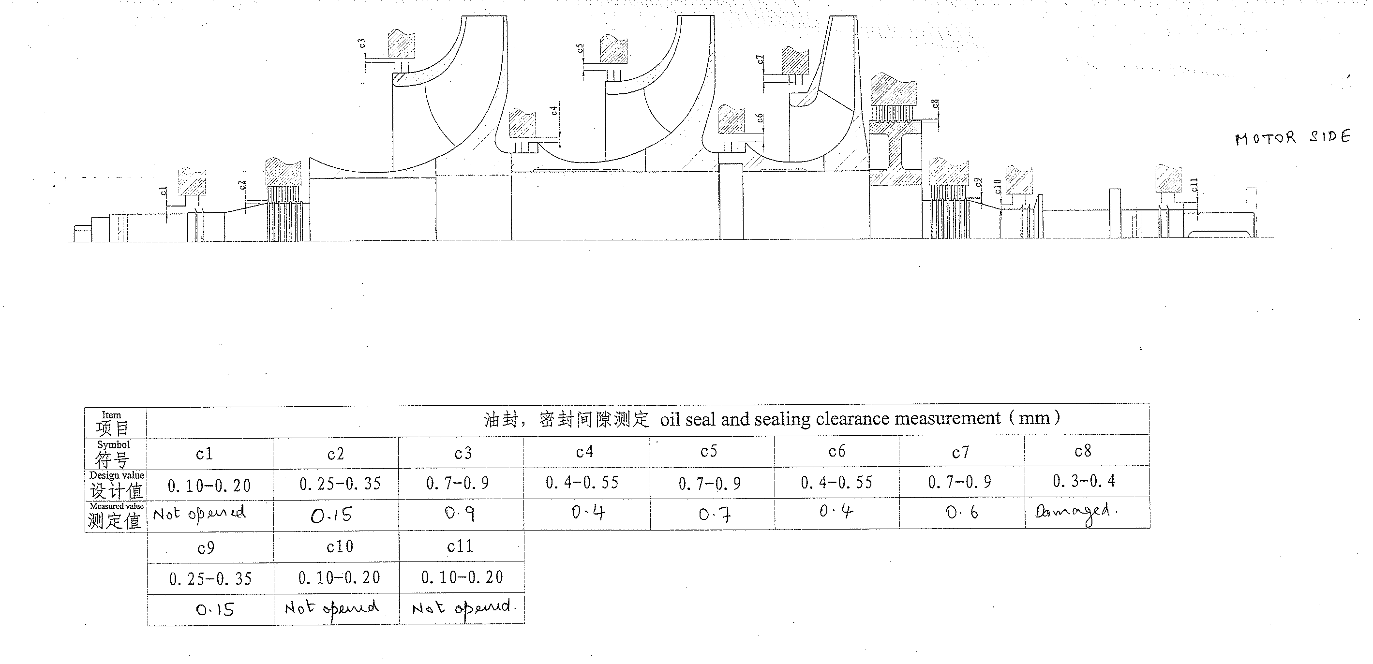

*Date: 27/05/2013*

The seal replacement job was started in the presence of representatives from MCC (OEM) who had arrived for supervising the replacement of the seal and for investigating the cause of failure of the seal.

During seal clearance checking which was done on 14/5/2013, the clearances of following seals were found to be out of acceptable limits

|  |  |  |  |
| --- | --- | --- | --- |
| *Sl no* | *Seal Nomenclature* | *Reqd clearance* | *Actual clearance* |
| 1 | C2 | 0.25-0.35 | 0.15 |
| 2 | C7 | 0.7-0.9 | 0.6 |
| 3 | C9 | 0.25-0.35 | 0.15 |

This was shown to MCC but they said that deviation of 0.1mm on either side of the limits is acceptable.

The dimensions and tolerance limits to be maintained while machining the spare seal were given by MCC.Please refer drawing no *2220-02174 B* for actual dimensions and tolerances to be maintained for machining the seal.

*Direction in which the seal is to be mounted*

While mounting the seal, it is to be ensured that the seal is mounted in the right direction. Please refer the sketch below

Dir of air flow Dir of air flow

Correct method where the sealing will be OK

Wrong method where sealing will not be proper

*Date: 28/05/2013*

Machining of the spare seal was done at PID machine shop. The seal was directly mounted on the chuck without any holding clamps as the seal was not getting properly centered on the chuck when mounted with clamps.

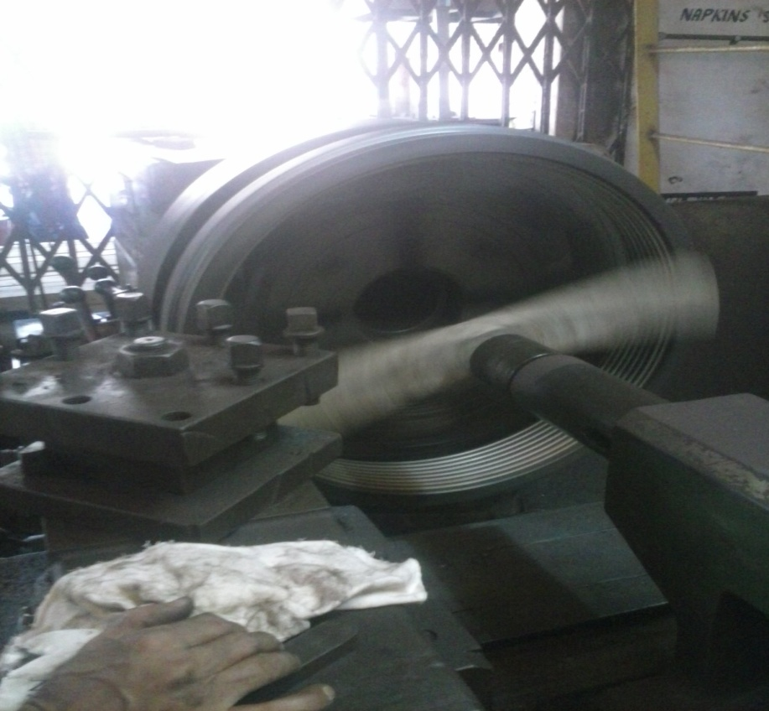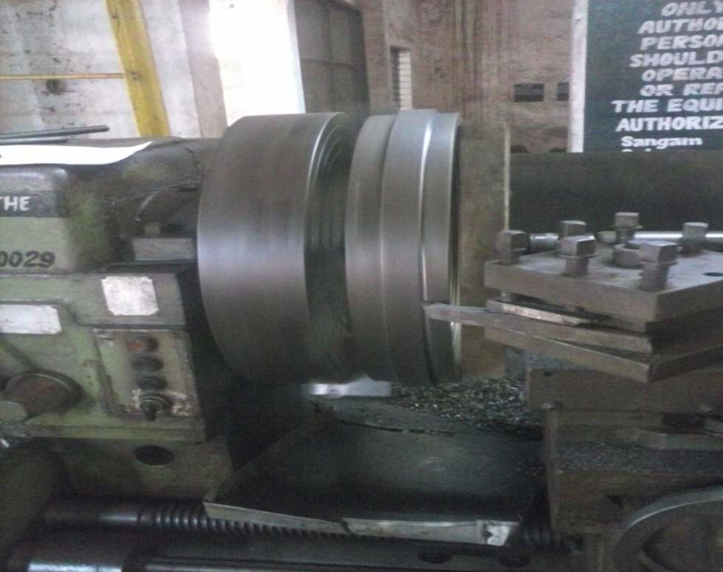

*Date: 29/05/2013*

The assembling of the machined seal was started.

1. The seal was cleaned thoroughly with AC 90 and was punched with a centre punch to ensure proper seating of seals.
2. The seal was checked thoroughly and slight bend was found at some locations. Same was made straight using a flat file.
3. The bottom half of the seal was then assembled with the casing and clearances were checked and were found to be as follows.

S/H side

PCM side

0.3mm

0.1mm

1. The seal was removed and filing was done on PCM side half of the labyrinth seal using a flat file. Prussian blue colour paste was applied on the seals and then filing was done so as to ensure that the filing is done uniformly. After filing, the seal was assembled with the casing and clearances were checked again.

PCM side

S/H side

0.3mm

0.2mm

Even though the seal clearances were not within the acceptable range of 0.3-0.4mm,it was decided go ahead with the tolerance level as suggested by MCC.As per MCC,deviation of 0.1mm on either side of the limits is acceptable.

1. The other half of the seal was then assembled and clearances were checked.

S/H side

PCM side

0.3mm

0.2mm

1. The seal was removed and filing was done on PCM side half of the seal. As before, prussian blue colour paste was applied on the seals and then filing was done so as to ensure that the filing is done uniformly. After filing the seal was assembled back and clearances were checked once again and was found to be within the limits(0.3mm to 0.4mm)

S/H side

PCM side

0.3mm

0.3mm

1. Once the clearances were set to the required limits, the assembling of the seal was done. The top half was assembled with the casing and locking bolts were put.
2. The casing flanges were cleaned thoroughly and anabond 610 sealant was applied.
3. The casing was put back. The freeness of the rotor was checked by rotating the rotor with the barring gear and was found to be OK.Then all bolts were put and were tightened properly.
4. The trials of the blower assembly were taken in presence of MCC representatives and were found to be OK. The vibration levels of the blower were within the acceptable limits. But slight rubbing sounds were heard from the blower when it was put off.

*Date: 30/05/2013*

Trials were taken again on 30/5/2013 and no sounds were heard from the impeller. The newly installed seal is suspected to be leaking slightly as sound of air leakage was observed from the drive end side of the rotor assembly. Same was checked by MCC expert conformed that this leakage would stop while in operation & clearance was given to take the blower assembly in line. The blower was taken in line at 01:30 PM and was found to be working fine.

MCC has pointed out that the cause of failure of the labyrinth seal could be excessive back pressure but the functioning of check valve at the discharge of blower was found to be OK.

*Important points to be taken care of while replacing the seal*

1. Clean the seal thoroughly before installation.
2. The seal should be machined as per dimensions in drawing no *2220-02174 B*.
3. The seal should be mounted in the right direction.
4. Ensure that the seal clearances are within the acceptable limits.
5. Apply prussian blue colour paste on the seal before filing so that filing will be uniform throughout the seal.
6. Ensure freeness of the impeller by rotating the rotor with barring motor after putting the casing.